Pre-lab: Characterization of Physical Properties
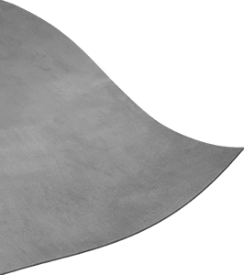
Katya Echazarreta
Karla Lopez

- Introduction

Goal: The goal of this experiment is to test different ways of cutting through the metallized polyester film to make sure that such material is fit for the automated tracing of robots that our research is focused on.

In our research, the vision is to create automatic traces for robot designs according to user’s specifications. One of the priorities to make this vision a reality is to find the perfect material that can be used to trace such patterns without causing electric malfunctions. To make sure that the material we use is adequate, we must first test some physical properties such as what happens when we cut through the aluminum coated plastic but we don't go all the way through? Will the traces made create a short circuit? Will they not? To answer such questions we must conduct an experiment to make sure such traces are not being affected when cutting through the material.

II. Components

The components that are required to conduct this experiment are the following:

- Aluminum coated plastic (2 6inx6in cutouts)
- Digital Multimeter
- Paper cutter
- Silhouette software
- Tape
- Wires

III. Experiment Setup/Procedure

Part 1: Setting up the Silhouette software

- Visit the website: https://www.silhouetteamerica.com/software to download a copy of the Silhouette software
- Once the software is downloaded, open up the program, go to file and select new. You should see something like this:
- 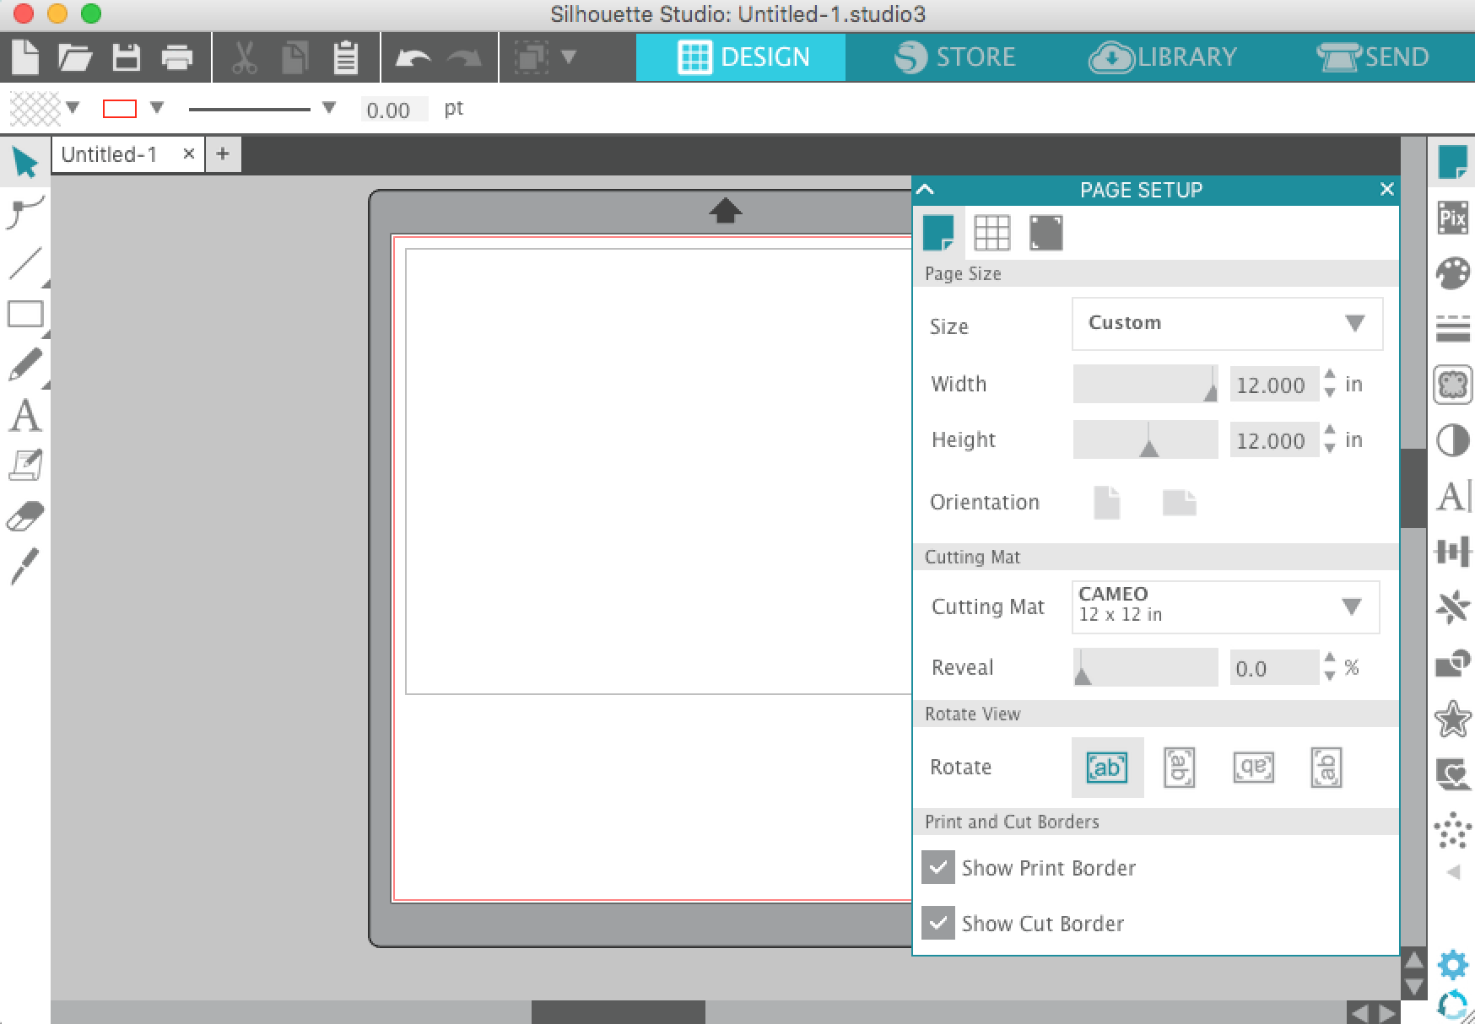
- Make sure the Design tab is selected, then click on the rectangle on the left side of the board to make a design of a rectangle pair of 2cmx8cm.
- If the previous step was followed correctly, the rectangle pair designed should look like this:
- Once the design is done, connect your computer to the usb cable from the paper cutter machine
- Turn on the paper cutter machine and make sure that the ratchet blade is set to 1. You can verify this by making sure a red line is under the number 1 on the blade.
- Load the tray with a 6inx6in cutout of the aluminum coated plastic.
- Once the machine has been loaded, go back to the Silhouette software and select the tab named SEND
- On that tab, before pressing send, make sure speed is set to 1 and force is set to 4.
- Once you’ve verified these parameters are correct, click send.
- After the design has been sent to the paper cutter, and once the job has finished cutting, unload the machine.
- Repeat steps 9 through 13 to get a second sample, except for this sample make sure speed is set to 1 and force is set to 5.
- Your design should be nicely carved on the aluminum coated plastic and the cuts should not be traced all the way through the material. If the cuts were actually made through the material, verify that the paper cutter’s blade was set up correctly to 1.

Part 2: Testing the Trace Patterns
A:
Sample 1 (force 4):
- Cut four pieces of tape and use each to tape the finalized traces by each corner to a table or flat surface.
- First set the Digital Multimeter to the Resistance $(Ω)$ setting and insert the black lead into the black COM label and the red lead into the red (V$Ω$) label.
- Once at this setting, place one lead (does not matter which color for measuring resistance) on the top of one trace pattern and the other on the bottom of the same trace. Record the result in the table below under “Resistance Measured across Trace (1 or 2)”.
- Follow step 3 once more for the second trace.
- Now, still at the Resistance setting, place one arbitrary lead on the top of one trace pattern and the other lead on the top of the other pattern. Record the result in the table below under “Resistance Measured between Trace 1 and 2 top”.
- With the lead still at the top of the first trace (numbering from left to right), take the lead that was on the top of the second trace and make the following four measurements:

Move the lead on the second trace down the trace to about .25 of the way down and record the value in the table under “Resistance Measured between Trace 1 and 2 top”

Next, move the lead down about .5 of the way down the trace and record the value in the table below under “Resistance Measured between Trace 1 and 2 top”

Next, move the lead down about .75 of the way down the trace and record the value in the table below under “Resistance Measured between Trace 1 and 2 top”

Next, move the lead down about .9 of the way down the trace and record the value in the table below labeled “Resistance Measured between Trace 1 and 2 top”.

7. Repeat step 6, but now place one lead on the top of the second trace and follow the steps to move down the first trace.
8. Repeat step 6, but now place one lead on the bottom of trace one and the next lead on the bottom of trace two; follow steps to move up (simple alter step 6 to move up instead of down) trace two.
9. Repeat step 6, but now place one lead on the bottom of trace one and the next lead on the bottom of trace two; follow steps to move up (simple alter step 6 to move up instead of down) trace trace one.
Sample 2 (force 5):
1.Repeat all steps for sample 1 using sample 2.

B:
Sample 1(force 4):
Using sample 1(force 4):
- First make sure the Digital Multimeter is set to the Resistance$(Ω)$ setting as previously explained in part A
- Place one of the leads of the multimeter at the top of the traces and the other lead on a random part of the circuit that is not a trace.
- Record the value of the resistance measured in the results section under table labeled “B.”
- Move the lead on the trace to approximately ¼ of the length of it while keeping the lead on the random place still. Record the resistance value shown on the multimeter on the results section under table labeled “B.”
- Move the lead on the trace to approximately ½ of the length of it while keeping the lead on the random place still. Record the resistance value shown on the multimeter on the results section under table labeled “B.”
- Move the lead on the trace to approximately ¾ of the length of it while keeping the lead on the random place still. Record the resistance value shown on the multimeter on the results section under table labeled “B.”
- Move the lead on the trace to approximately the bottom part of it while keeping the lead on the random place still. Record the resistance value shown on the multimeter on the results section under table labeled “B.”
- Repeat steps 1-8 for the second trace.

Sample 2(force 5):
- Repeat steps 1-8 from Sample 1 except this time we are using the sample 2 with force 5.

C:

- Using our pre-cut trace patterns bend the vertical traces halfway horizontally.
- From previous parts of the experiment, make sure the Digital Multimeter is set to the resistance$(Ω)$ setting.
- Repeat parts 2 sections A and B of the experiment except this time record your values under the Results section labeled C.a and C.b.

IV. Results:

Part 1:
Insert a picture of the design of one of the pairs made in the Silhouette software:

Part 2:

Results part 2A
A. | Resistance Measured across Trace 1 | Resistance Measured across Trace 2 | Resistance Measured between Trace 1 and 2 top | Resistance Measured between Trace 2 and 1 top | Resistance Measured between Trace 1 and 2 bottom | Resistance Measured between Trace 2 and 1 bottom
Sample 1 (Force 4) |  |  | Top:  ~¼:  ~½:  ~¾:  Bottom: | Top:  ~¼:  ~½:  ~¾:  Bottom: | Top:  ~¼:  ~½:  ~¾:  Bottom: | Top:  ~¼:  ~½:  ~¾:  Bottom:
Sample 2 (Force 5) |  |  | Top:  ~¼:  ~½:  ~¾:  Bottom: | Top:  ~¼:  ~½:  ~¾:  Bottom: | Top:  ~¼:  ~½:  ~¾:  Bottom: | Top:  ~¼:  ~½:  ~¾:  Bottom:

Results part 2B

B. | Resistances measured between trace 1 and random spot | Resistances measured between trace 2 and random spot
Sample 1 (Force 4) | Top:  ~¼:  ~½:  ~¾:  Bottom: | Top:  ~¼:  ~½:  ~¾:  Bottom:
Sample 2 (Force 5) | Top:  ~¼:  ~½:  ~¾:  Bottom: | Top:  ~¼:  ~½:  ~¾:  Bottom:

Results part 2C

C.a | Resistance Measured across Trace 1 | Resistance Measured across Trace 2 | Resistance Measured between Trace 1 and 2 top | Resistance Measured between Trace 2 and 1 top | Resistance Measured between Trace 1 and 2 bottom | Resistance Measured between Trace 2 and 1 bottom
Sample 1 (Force 4) |  |  | Top:  ~¼:  ~½:  ~¾:  Bottom: | Top:  ~¼:  ~½:  ~¾:  Bottom: | Top:  ~¼:  ~½:  ~¾:  Bottom: | Top:  ~¼:  ~½:  ~¾:  Bottom:
Sample 2 (Force 5) |  |  | Top:  ~¼:  ~½:  ~¾:  Bottom: | Top:  ~¼:  ~½:  ~¾:  Bottom: | Top:  ~¼:  ~½:  ~¾:  Bottom: | Top:  ~¼:  ~½:  ~¾:  Bottom:

C.b | Resistances measured between trace 1 and random spot | Resistances measured between trace 2 and random spot
Sample 1 (Force 4) | Top:  ~¼:  ~½:  ~¾:  Bottom: | Top:  ~¼:  ~½:  ~¾:  Bottom:
Sample 2 (Force 5) | Top:  ~¼:  ~½:  ~¾:  Bottom: | Top:  ~¼:  ~½:  ~¾:  Bottom:

Experiment Question:

If we fold the traces will they still work the same as before they were folded?

Conclusion:

What do the measured resistance values mean?

A.

If a variable resistance (R<∞) is detected when measuring the resistance between two points on the same trace pattern, then this means that the trace is acting as a properly conductive wire with a resistance value.

However, if “0.L” is detected when measuring the resistance between two points on the same trace pattern, then this means that the trace itself is creating an open loop and is therefore not acting as a properly conductive wire.

If a variable resistance (R<∞) is detected when measuring the resistance between trace one and two, then this means that the traces are somehow connecting and are shorting. In this case, they are therefore not acting as a properly conductive electrically isolated wires.

However, if a “0.L” was detected when measuring the resistance between trace one and two, then this means an infinite resistance was measured. Meaning that the multimeter detected an open loop. In our case, an open loop between traces is desirable because this means the traces are electrically isolated.

B.

If a “0.L” was detected when measuring the resistance between trace one and a random part on the aluminum coated plastic, then this means an infinite resistance was measured. Meaning that the multimeter detected an open loop. In our case, an open loop between traces and the rest of the circuit is desirable because this means the traces are electrically isolated.

However, if a resistance (R<∞) is detected when measuring the resistance between one trace and a random part on the aluminum coated plastic then this would act as a short circuit showing that they are electrically connected.

C.

For part C, the same conditions previously mentioned in this section part A and B should apply for the new state.

